

**AUTO BED LEVELLING GUIDE**

Thanks to OderWat for the actual bed levelling method and another huge thanks to Ben Lye for all the Troubleshooting I’ve seen him do on this topic on the group. Advice I’ve picked up from Ben that I’ve relayed has gone on to help many users who were still having uneven first layers even with auto levelling. Which brings me to my next point….

**\*\*\*Disclaimer\*\*\***

**Auto bed Levelling is NOT magic.** There are a lot of factors involved that can still cause problems with first layers. As stated in the Firmware install guide. You should already have a working sensor at this point (tested with M119). Don’t just trust the light on the sensor itself- make sure you run the command and see the z min in its different states before carrying on. otherwise you likely could end up with a nozzle crash.

**\*\*\*Quick Guide\*\*\***

This section is just to lay out the commands to configure the z offset in 11 easy to follow steps. Newbies and those not familiar with Cura may want to skip this quick guide and see the more in depth guide afterwards.

1. Preheat Nozzle and Bed
2. M851 Z0 - reset Z offset to “0”
3. M500 – Save to EEPROM
4. G28 – Auto Home (sensor will be centred at this point)
5. G1 X110 Y110 / (G1 X110 Y135 if you have an A2 with 220x270 bed) - move nozzle to centre
6. Move Nozzle down to the correct gap (about the thickness of a4 paper)
7. G92 Z0 – This tells the printer that “This is now Z0”
8. G30 X110 Y110/ (G30 X110 Y135 if you have an A2 with 220x270 bed)

-Tests the trigger distance and displays the offset as a positive value e.g Z2.1

1. M851 Z<insert offset here as a negative value> (eg. M851 Z-2.1)
2. M500 – Save to EEPROM
3. Add a G29 After the G28 in your start g code to activate auto bed levelling.

**\*\*\*Full Setup and Auto Bed Levelling Guide\*\*\***

**Step 1: Installing and configuring Cura 15.04.6**

First locate the Cura 15.04.6 application and double click to open it.

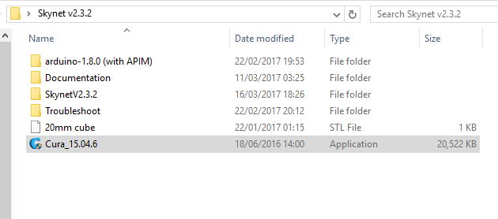

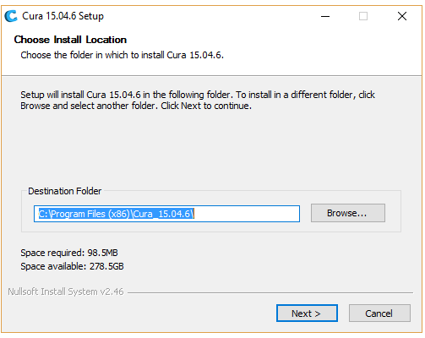you may get a user account window popping up- click YES.

Then on this window

Click Next >

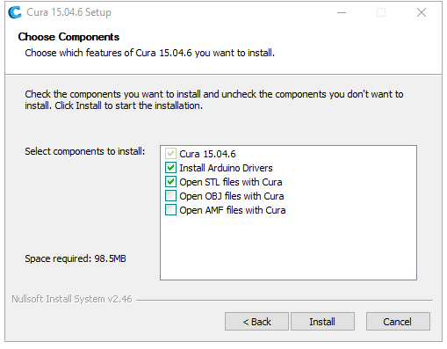

Click Install

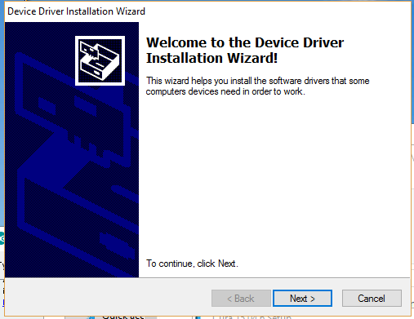

Click Next >

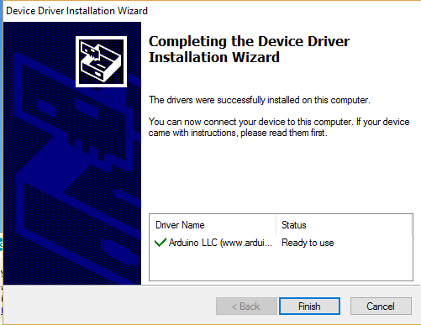

Click Finish

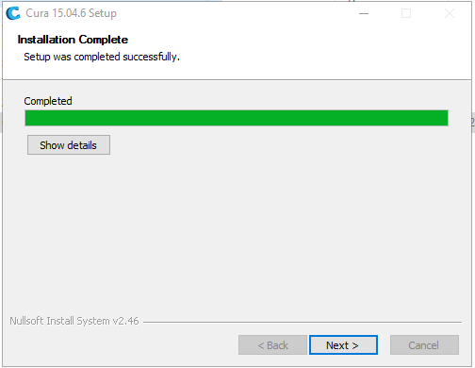

Click Next >

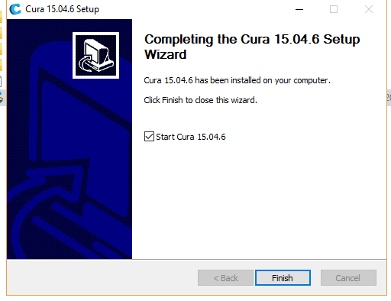

Click Finish

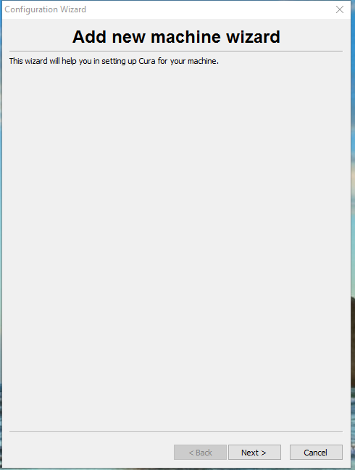

Now we are going to add our machine settings into cura..

Click Next >

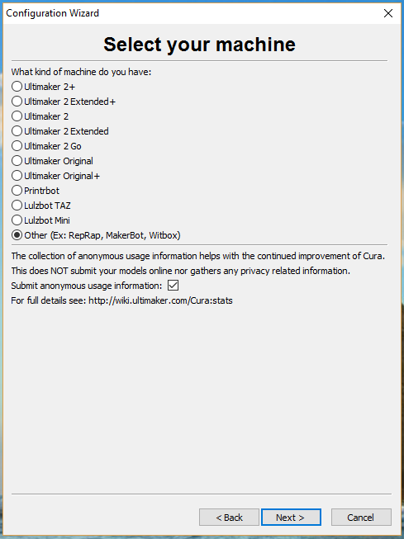

Select “Other”

And

Click Next >

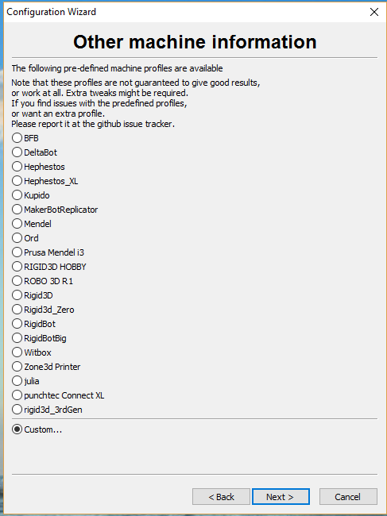

Select “Custom…”

And

Click Next >

Now input the machine build volume settings for your printer 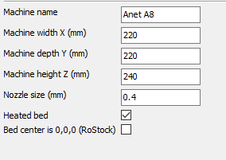 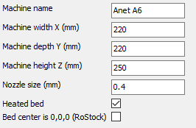

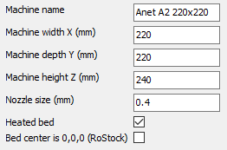 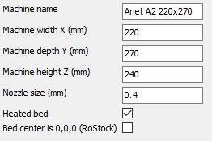

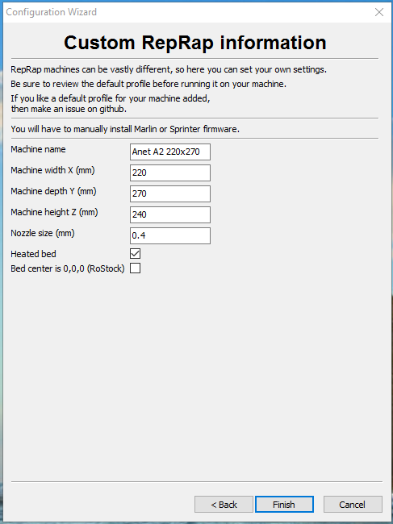

And Finally

Click Finish

**Welcome to Cura 15.06.4 😊**

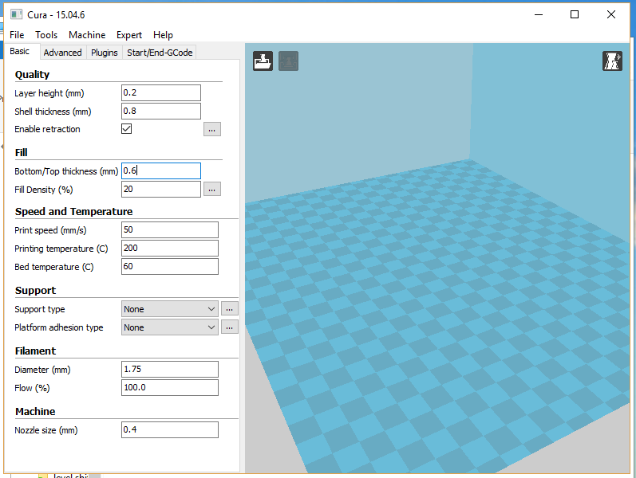

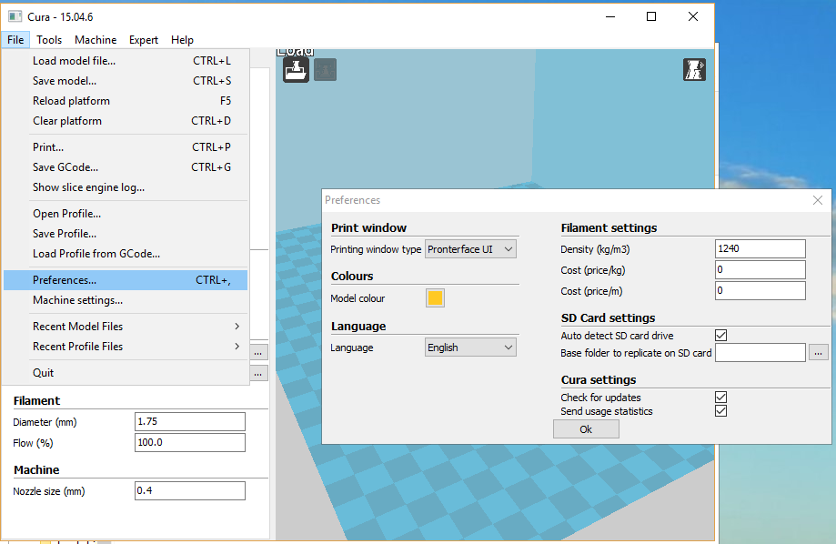Go to File , Preferences and change the Printing window type to Pronterface UI

Go to “Machine” – Machine Settings and make sure the Serial Port and Baudrate is set correctly. Once done – Click Ok

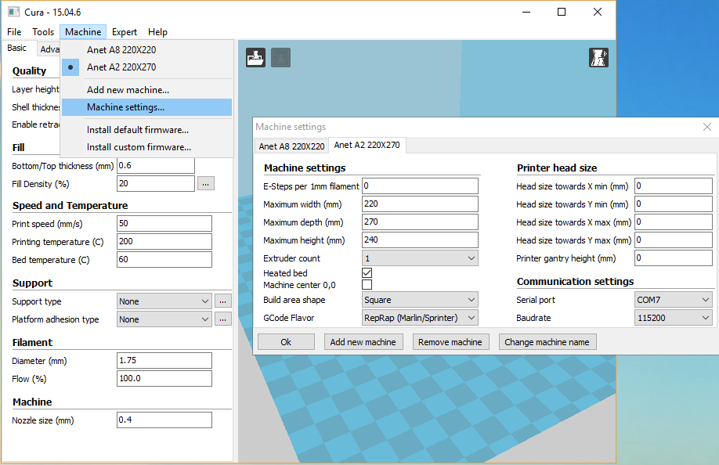*You can refer to the Skynet firmware Installation Guide on how to find the correct com port in the Device Manager. Baudrate is 115200 by default with Skynet.*

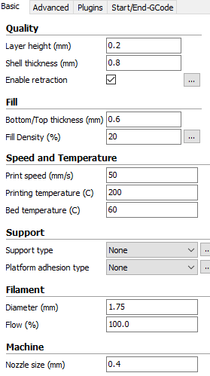

Now you want to make sure the basic settings are correct for the specific filament you will be using.

Especially “Filament Diameter” as Cura come preset at 2.85mm but Anet printers all use 1.75mm filament

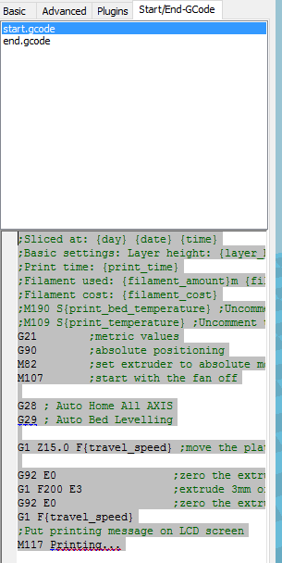Now go to the Start/End-GCode tab and edit the start.gcode by pasting in this;

;Sliced at: {day} {date} {time}

;Basic settings: Layer height: {layer_height} Walls: {wall_thickness} Fill: {fill_density}

;Print time: {print_time}

;Filament used: {filament_amount}m {filament_weight}g

;Filament cost: {filament_cost}

;M190 S{print_bed_temperature} ;Uncomment to add your own bed temperature line

;M109 S{print_temperature} ;Uncomment to add your own temperature line

G21 ;metric values

G90 ;absolute positioning

M82 ;set extruder to absolute mode

M107 ;start with the fan off

G28 ; Auto Home All AXIS

G29 ; Auto Bed Levelling

G1 Z15.0 F{travel_speed} ;move the platform down 15mm

G92 E0 ;zero the extruded length

G1 F200 E3 ;extrude 3mm of feed stock

G92 E0 ;zero the extruded length again

G1 F{travel_speed}

;Put printing message on LCD screen

M117 Printing...

You only actually need a G28 followed by a G29 in order to have functioning Auto bed levelling.

Ok so that’s all done for installing and configuring Cura 15.06.4 – you are now ready to set up the z offset and print.

Step 2 – Configuring Z offset using Pronterface UI

First Click Load- browse to the “20mm cube.stl” file in the Skynet download and click Open

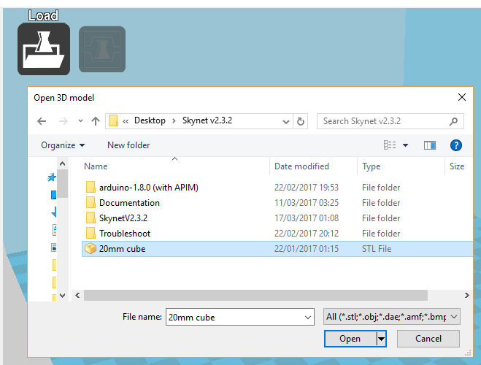

Now click the “Print wish USB” button to bring up the Pronterface UI window. If you have followed the guide to the letter by this point you should get the word “operational” in the top left corner of this window 😊

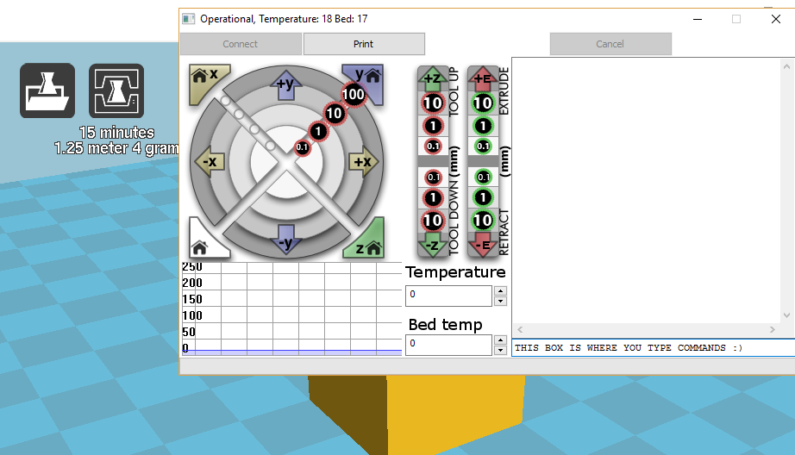

Ok – we are now basically going to run through the Quick Guide again only this time I will explain what it all does in a bit more detail 😊

Make sure your Auto levelling sensor is higher up than the nozzle- you want the nozzle itself to be the lowest point in the carriage assembly to prevent anything crashing into your print. About 1-2mm is about the usual height difference that people go for.

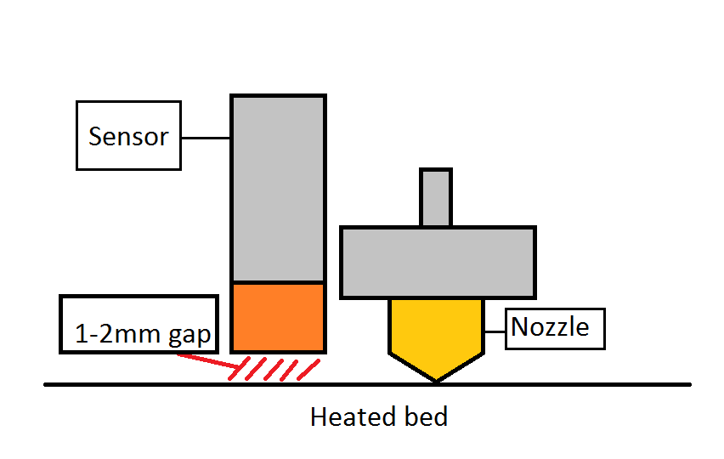

Step 1.

Preheat nozzle and bed- I do this by filling in the Temperature and Bed temp boxes and then to activate those temps just click in box where you type commands and press Enter on your keyboard.

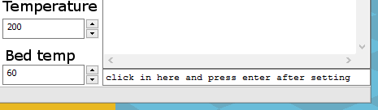

Now you will see the temps rising. Once they have reached temperature. leave it 5 minutes for all the metal to thermally expand. This will give more accurate sensor readings.

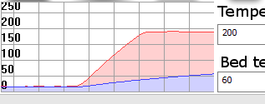

Step 2. Send the M851 Z0 command by typing that into the box (Case sensitive) and hit enter this will zero any current z offset. Always do this before configuring the z offset!!

Step 3. send M500 – to store the setting to the EEPROM

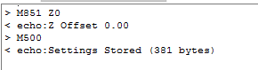

Step 4.

Send G28 and hit enter. This is the Home all axis command and will zero the x and y axis – then move the sensor to the centre of the bed and lower until the sensor triggers then it will raise Z to 10. Please note that at this point the nozzle will not be centred on the print bed. it looks odd but I assure you this is perfectly normal! Also, when it says 10- it is actually 10mm+ the z offset which we don’t know yet!



Step 5. Make sure to choose the correct command here!

send G1 X110 Y110 If you have a 220x220 heated bed – the majority of people will be using this command.

Send G1 X110 Y135 🡨 ONLY IF YOU ARE AN A2 USER WITH THE 220X270 HEATED BED (I’m setting up my a2 while writing this guide)

This step will bring the nozzle to the centre- all you OCD people will be feeling relieved at this point because the nozzle will now move to a more centralised position!

Step 6. Move the nozzle down to the correct Gap. – we achieve this by using the buttons in the Pronterface UI window .

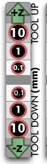 As we saw after the Auto home (G28) the nozzle raised itself to what it thinks to be as 10. so first we might as well lower it back down 10mm. press the -Z 10 button in pronterface to do this.

Now the printer will think it’s at Z0 but in actual fact when you look at the nozzle. it’s still up in mid air.

Place a sheet of A4 paper on your heated bed and continue lowering the nozzle down in 0.1 increments until it just touches the paper. The paper should still be able to move without ripping but you should feel a tiny bit of friction when passing it through the gap between the nozzle and the heated bed!

Step 7. Send G92 Z0 - this will tell the printer that this new location is Z 0



Step 8. This step is similar to step 5 except with a G30 instead of a G1

send G30 X110 Y110 If you have a 220x220 heated bed – the majority of people will be using this command.

Send G30 X110 Y135 🡨 ONLY IF YOU ARE AN A2 USER WITH THE 220X270 HEATED BED (I’m setting up my a2 while writing this guide)

This step will raise the nozzle and bring it back down until the sensor triggers. Then it will display the z offset output as a positive value in the Pronterface ui window

You then add the negative symbol– onto this number for your z offset.

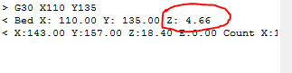

Step 9. Send M851 Z-4.66 (or whatever your offset is)

This command will now set the Z offset to -4.66. z offset should typically be negative as it’s the point from where the printer thinks is 0 (sensor trigger point in midair) to perfect squish on the bed.

Step 10. Send M500 to store this new z offset setting into the EEPROM

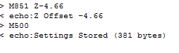

Now you are ready to actually Print the cube.

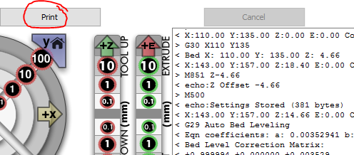

And that’s it! You should now have fully functioning auto bed levelling.

But…

That still doesn’t mean that it will be perfect first go... like I said right at the beginning. Auto bed levelling is NOT magic. As I’ve been writing this guide I’ve actually been configuring the new A2 (thanks donators 😊) which has actually never printed anything. My cube and first ever print on this machine came out lovely but I did notice while it was laying down the first layer that it was a bit too close for my liking. Which only means that on step 6 -there must have been a little too much friction on the paper.

So now I’m going to edit my z offset with a bit of trial and error and try -4.6 run a test print and that should just about do it! M851 Z-4.6 then M500

***Still Having Troubles??***

The information below has been copied from the 3dprint.wiki- I think this was written by Ben lye- so thanks for that Dude and apologies if there were any other contributors!

Troubleshooting

Automatic bed levelling is a complex beast. When set up well it can work extremely well, but if it isn't working well for you, there are a few basic things to check.

A very typical problem scenario is where the print is fine on one edge or in the middle, but the nozzle is too near the bed in one corner or on one edge. In this case, the first thing to check is if the [probe X and Y offsets are correct](https://3dprint.wiki/reprap/anet/a8/improvement/autobedleveling?s%5b%5d=auto#are_your_x_and_y_offsets_correct).

Another common problem is the nozzle being too high above the bed when printing starts. This is often caused by [the Z offset being incorrect](https://3dprint.wiki/reprap/anet/a8/improvement/autobedleveling?s%5b%5d=auto#is_your_z-offset_correct).

These problems, and many others, can be solved by working through these simple troubleshooting steps.

Is the bed as flat and level as it can be?

ABL can't work miracles. You need to make sure your bed is as level as you can get it by adjusting the corner screws. When you have ABL working well you may like to consider to swap the springs and screws for fixed stands. (Like these, for example [http://www.thingiverse.com/thing:2165389](https://www.thingiverse.com/thing:2165389).)

There's no magic number for how flat your bed needs to be, but you probably want any variations to be no more than 1mm across the entire bed. You can check it manually by laying a straight edge (such as a steel rule) across it, or using your probe by increasing the number of probed points using the instructions under 'Measuring your bed flatness'.

Which levelling method are you using?

The two main levelling methods in Marlin are linear and bilinear. Linear creates a single tilted plane, and is best suited to a perfectly flat surface which is tilted lower or higher on one side or corner. Bilinear is best suited to an uneven bed with dips and rises, and is the Marlin-recommended method.

It is unlikely that your bed is perfectly flat, so bilinear is usually a good option, especially if linear does not give good results.

<http://marlinfw.org/docs/features/auto_bed_leveling.html>

Is your probe working well?

One of the first things you should do after installing your Z-probe is check how well it works using the M48 command to test it.

In order to run M48 you need to uncomment this line in configuration.h:

#define Z_MIN_PROBE_REPEATABILITY_TEST

Use commands like this to run 10 probes and get the measurements:

M48 P10 X100 Y100

The output will look similar to this:

M48 Z-Probe Repeatability Test

Finished!

Mean: 3.450000 Min: 3.442 Max: 3.452 Range: 0.010

Standard Deviation: 0.004330

This shows the absolute maximum and minimum measurements the sensor took, the mean (average) of all the measurements, the range between the maximum and minimum, and the standard deviation.

The standard deviation is interesting because it tells us that 68% of all the measurements were within 0.00433mm (one standard deviation) of either side of the mean, and 95% of the measurements were within 0.00866 (two standard deviations) of the mean.

A good probe should consistently give a range in the hundredths of mm, e.g. 0.05mm. A very good probe will have a range in the thousandths.

More information about standard deviation: <https://en.wikipedia.org/wiki/Standard_deviation>

If you get a very large range or standard deviation you should consider replacing your probe, or looking for sources of movement in your Z-axis. The motor couplers can contribute to excess play and you can consider upgrading them to better ones.

Probe area

You should do the M48 probe test in multiple places across your build area to ensure your probe is consistent everywhere. If you're using a capacitive sensor, make sure you check at the extremes of your probing grid to make sure you're not suffering from any wrap-around near the bed edges.

These lines in configuration.h define the probing grid boundaries:

#define LEFT_PROBE_BED_POSITION 35

#define RIGHT_PROBE_BED_POSITION 200

#define BACK_PROBE_BED_POSITION 180

#define FRONT_PROBE_BED_POSITION 20

Some tips for probe accuracy

* The 'spring' type Z-motor couplers allow vertical play, which can affect the Z-probe results. You can replace them with 'Plum' style couplers (like http://www.ebay.co.uk/itm/320969288677?var=5100767295527) which have no vertical movement.
* Capacitive probe measurements will vary near the edge - ensure that your probe boundaries are far enough from the edge to avoid this.

Are you probing enough points?

If your bed is curved or particularly warped you can increase the number of points the probe measures in order to create a more detailed correction matrix (at the expense of time - more probes means G29 takes longer).

Try a 5×5 or 7×7 grid by changing this line:

#define ABL_GRID_MAX_POINTS_X 5

Are your X and Y offsets correct?

For ABL to work correctly it is **essential** that the printer knows the exact offset from the nozzle to the probe, otherwise any correction is not going to be applied in the right place, and it may look like the printer isn't correcting at all.

If you downloaded SkyNet3D and used one of the example configurations, it probably came with some pre-configured probe offsets and a recommended sensor mount for you to print. It is absolutely vital that you check the sensor offsets once your probe is installed, and update the values in configuration.h accordingly.

These are the relevant lines:

#define X_PROBE_OFFSET_FROM_EXTRUDER 65 // X offset: -left +right [of the nozzle]

#define Y_PROBE_OFFSET_FROM_EXTRUDER -36 // Y offset: -front +behind [the nozzle]

Typically, sensors are most sensitive in the center, so we need to know the offset from the tip of the nozzle to the center of the probe. Here is an approach you can use to measure it:

Measuring X and Y offsets

1. Measure the bed and make a mark in the center (X110 Y110)
2. Home the printer then move to X110 Y110 Z0
3. If the nozzle is not on the mark you will need to make small movements to get it on the mark
4. With the nozzle on the mark in the center of the bed, measure the X and Y distance from the edge of the bed to the side of the probe
5. Measure the diameter of the probe
6. The probe offset values are 110 - [the distance from the bed edge to the probe] + [probe diameter / 2]

The offset parameters are integers, so round your results to whole numbers before updating configuration.h

Is your Z-offset correct?

Getting the Z-offset right is critical to get your first layer. Use this process to find and set it:

1. Heat your printer up to your printing temperature and allow a few minutes for it to expand and settle
2. Reset the existing Z-offset to zero

M851 Z0

1. Home all axes

G28

1. Move the nozzle to the middle

G1 X110 Y110

1. Move the nozzle down so it is just gripping a piece of standard printer paper
2. Mark this position as Z zero

G92 Z0

1. Use the sensor to probe the middle of the bed (where we just set Z0)

G30 X110 Y110

1. Take the Z value of the bed and put a minus sign in front; this is the Z-offset. E.g. 1.23 becomes -1.23
2. Set the Z-offset

M851 Z-1.23

1. Store it to the EEPROM

M500

Did you let it warm up?

Before setting your Z-offset you need to make sure your printer is up to temperature and you've given it a few minutes for any thermal expansion to occur. Differences in nozzle height of around 0.2mm have been observed between a hot and a cold nozzle. If you set your Z-offset with the nozzle cold, you will most likely find it is too close to the bed when it is hot.

You should also ensure that the printer has had sufficient time at temperature before starting a print. Ideally give the printer 3-5 minutes after it reaches printing temperatures before you start to print.